Topology
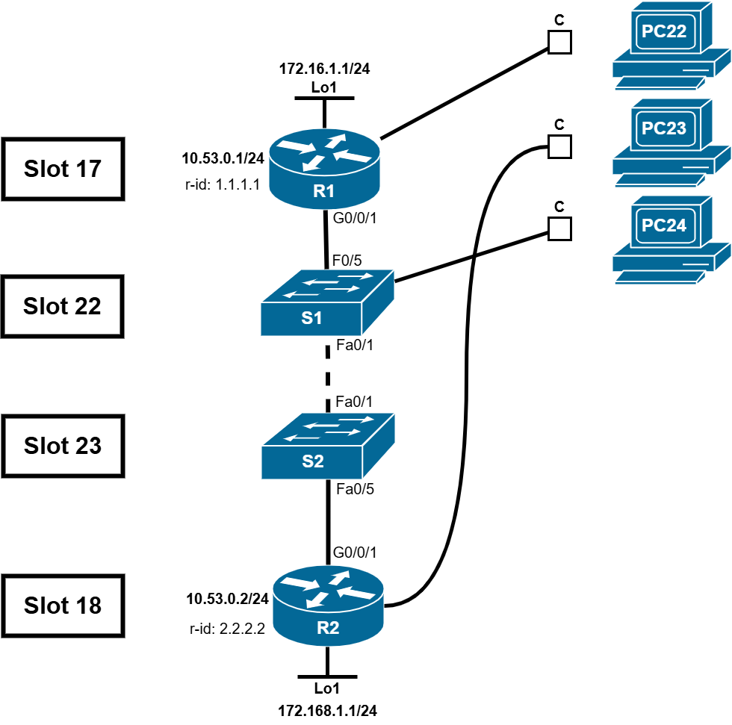

R1
en
conf t
hostname R1
no ip domain lookup
line console 0
logging synchronous
end

int g0/0/1
ip add 10.53.0.1 255.255.255.0
no shut
int Loopback1
ip add 172.16.1.1 255.255.255.0
no shut

router ospf 56
router-id 1.1.1.1
network 10.53.0.0 0.0.0.255 area 0
network 172.16.1.0 0.0.0.255 area 0

end
sh ip ospf nei

sh ip route ospf

ping 192.168.1.1
traceroute 192.168.1.1

conf t
int g0/0/1
ip ospf 56 area 0
ip ospf priority 50
ip ospf hello-interval 30
ip ospf dead-interval 120

exit
ip route 0.0.0.0 0.0.0.0 Loopback1
router ospf 56
default-information originate
auto-cost reference-bandwidth 1000
end
clear ip ospf process

end
sh ip ospf int g0/0/1

R2
en
conf t
hostname R2
no ip domain-lookup
logging synchronous
end

int g0/0/1
ip add 10.53.0.2 255.255.255.0
no shut
int Loopback1
ip add 192.168.1.1 255.255.255.0
no shut
exit
int Loopback1
ip ospf 56 area 0

router ospf 56
router-id 2.2.2.2
network 10.53.0.0 0.0.0.255 area 0
network 192.168.1.0 0.0.0.255 area 0

end
sh ip ospf nei

sh ip route ospf

conf t
int Loopback 1
ip ospf 56 area 0

int g0/0/1
ip ospf hello-interval 30

int loopback 1
ip ospf network point-to-point

exit
router ospf 56
passive-interface Loopback1
auto-cost reference-bandwidth 1000
clear ip ospf process

end
sh ip route ospf
ping 172.16.1.1
traceroute 172.16.1.1

S1
en
conf t
hostname S1
no ip domain-lookup

S2
en
conf t
hostname S2
no ip domain-lookup

EIGRP vs. OSPF

EIGRP(Cisco Propie) | OSPF
router eigrp ?  router-id ?  network <network address> <willcart mask>  passive-interface <>  no auto-summary  redistribute static | router ospf ?  router-id ?  network <network address> <willcart mask> area 0  passive-interface <>  default-information originate
Additional of OSPF

int g0/0/0
ip ospf <process id> area 0
ip ospf cost ?
ip ospf priority ?
ip ospf hello-interval ?
ip ospf dead-interval ?

*passive interface = do not share router information to the interface

OSPF very smart
Select one DR(Designated router) as monitor
Other one become BDR (backup )
Will share to DR then it compile (no need everyone listen each other, busy busy)

